Chromoendoscopy

CHROMOENDOSCOPY REPORTING CHECKLIST
(esophagus, stomach)
🔹 1) Stain Used (multi-select)
- ⬜ Lugol’s iodine
- ⬜ Acetic acid
- ⬜ Indigo carmine
- ⬜ Methylene blue
- ⬜ Other (specify): ______

🔹 2) Pre-staining Assessment
(Describe lesion BEFORE stain)
Lesion type:
- ⬜ Flat
- ⬜ Slightly elevated
- ⬜ Depressed
- ⬜ Nodular
- ⬜ Irregular mucosa
- ⬜ Patch of altered color
- ⬜ Vascular pattern abnormal

3) Findings AFTER STAINING (Select stain-specific fields)

🟤 A) Lugol’s Iodine Reaction
Staining pattern
- ⬜ Uniform deep brown staining (normal)
- ⬜ Heterogeneous staining
- ⬜ Faint staining
- ⬜ Iodine-voiding area(s) → pale / unstained patch
Characteristics of iodine-voiding area
- ⬜ Single lesion
- ⬜ Multiple lesions
- ⬜ Well-demarcated border
- ⬜ Irregular border
- ⬜ Flat
- ⬜ Slightly elevated
- ⬜ Depressed
- ⬜ Surrounding mucosa stains normally
Pink-color sign (after 1–3 minutes)
- ⬜ Present (high-risk)
- ⬜ Absent
- ⬜ Not assessed
Size of unstained lesion
- ___ mm
- ⬜ Circumferential involvement

⚪ B) Acetic Acid Reaction
Acetowhitening response
- ⬜ Uniform whitening (normal)
- ⬜ Patchy whitening
- ⬜ Delayed whitening
- ⬜ No whitening
Fade time (loss of whitening)
- ⬜ >30 seconds (normal)
- ⬜ 10–30 seconds
- ⬜ <10 seconds (suspicious for dysplasia)
Surface features after whitening fades
- ⬜ Irregular surface pattern
- ⬜ Nodular area
- ⬜ Depressed area
- ⬜ Irregular pit pattern
- ⬜ Abnormal vascular pattern

🔵 C) Indigo Carmine Contrast Enhancement
- ⬜ Mucosal topography enhanced evenly (normal)
- ⬜ Uneven pooling
- ⬜ Highlighted depression
- ⬜ Highlighted nodularity
- ⬜ Abnormal pit pattern revealed

D) Methylene Blue Uptake
- ⬜ Uniform blue staining
- ⬜ Patchy uptake
- ⬜ Loss of uptake area
- ⬜ Irregular uptake pattern
- ⬜ Non-staining suspicious zone
4) Targeted Biopsy Plan
- ⬜ Targeted biopsy taken from abnormal stained area
- ⬜ Mapping biopsy
- ⬜ EMR planned
- ⬜ ESD planned
- ⬜ No biopsy (reason): ______

⭐ 5) Overall Impression Based on Chromoendoscopy
(Check one)
- ⬜ No suspicious features
- ⬜ Suspicious for low-grade dysplasia
- ⬜ Suspicious for high-grade dysplasia
- ⬜ Suspicious for early carcinoma
- ⬜ Multifocal lesions
- ⬜ Indeterminate — requires histology

Hint- Draw table
Dye | Normal | Abnormal (Dysplasia / Cancer)
Lugol’s iodine | Uniform brown staining | Unstained/pale areas; pink-color sign
Acetic acid | Uniform whitening (lasts 30–60 sec) | Rapid fade of whitening; irregular surface
Methylene blue | Even blue uptake | Patchy / reduced uptake
Indigo carmine | Enhances pit pattern evenly | Irregular pits / depressions / nodules

Esophageal Glycogen Nodules
(esophagus)
Number
- ⬜ Few
- ⬜ Multiple
- ⬜ Diffuse
Appearance
- ⬜ Small whitish nodules
- ⬜ Smooth, round, well-defined

Xanthoma
(esophagus, stomach)

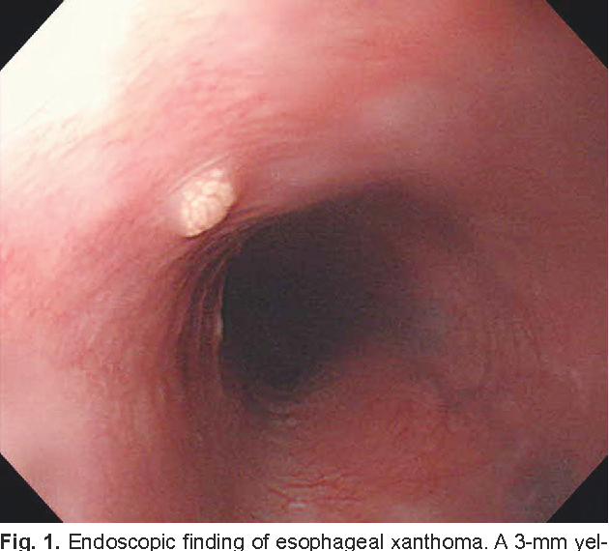

https://www.semanticscholar.org/paper/Xanthoma-of-the-Esophagus-Bang-Kim/eafc3916b9067c8120957c726275d0a1afd24cda

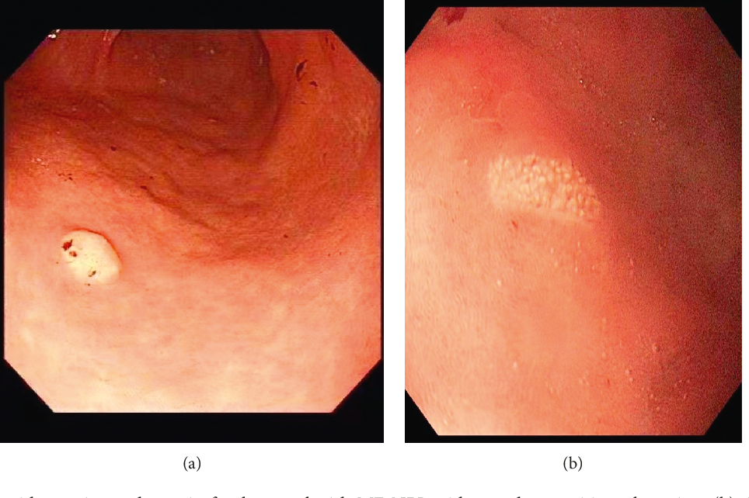

https://www.semanticscholar.org/paper/Gastric-Xanthoma-Associated-with-Gastric-Cancer-An-Moumin-Mohamed/c8aaae19eec2badb7932dea714061f060baace6b
Appearance (multi)
- ⬜ Yellow or yellow-white plaque
- ⬜ Discrete, well-defined
- ⬜ Flat or slightly elevated
- ⬜ Smooth surface
Number
- ⬜ Single
- ⬜ Multiple
Biopsy
- ⬜ Not required (typical appearance)
- ⬜ Biopsy taken (if atypical / diagnostic uncertainty)

⭐ Ectopic Sebaceous Glands
Appearance (multi)
- ⬜ Yellow / yellowish-white spots
- ⬜ Small, round, well-defined
- ⬜ Smooth surface
- ⬜ Non-ulcerated
Number
- ⬜ Few
- ⬜ Multiple
Biopsy
- ⬜ Not required (typical appearance)
- ⬜ Biopsy taken (if atypical / diagnostic uncertainty)

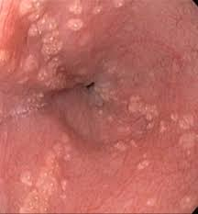

https://casereports.bmj.com/content/12/12/e232736

NON-SPECIFIC GASTRIC FINDINGS
(stomach)
Erythema
  - Extent
    - Diffuse
    - Patchy
    - Focal
  - Location (multi)
    - Antrum
    - Body
    - Fundus

2) Surface Changes
- ⬜ Edematous mucosa
- ⬜ Granularity
- ⬜ Nodular mucosa
- ⬜ Prominent folds

3) Erosions
- Number
    - ⬜ Single erosion
    - ⬜ Few erosions (2–5)
    - ⬜ Multiple erosions (>5)
- Location (multi)
    - ⬜ Antral erosions
    - ⬜ Body erosions

